Lab Assignment No: 05

NAME: Vivek Pundkar ROLLNO: 77

CLASS: C BRANCH: ENTC BATCH: 3

-----------------------------------------------------------------------------------------------------------------------

**Problem statement:**

Write a stored procedure namely procedure_grade for the categorization of the student if marks scored by the student in the examination is <=1500 and marks>=990 then the student will be placed in the distinction category. If marks scored are between 989 and 900 then the category is 1st class, if marks are between 899 and 825 then the category is higher 2nd class.

1. Creating required tables:

o Table student_marks:



o Table result:

2. Store procedure:

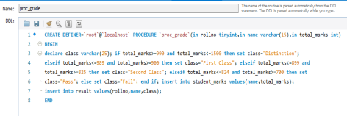

3. Calling stored procedure & adding Data: 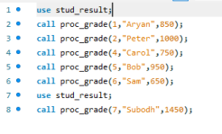

4. select * from result;

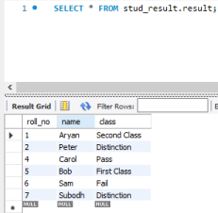

5. select * from stud marks;

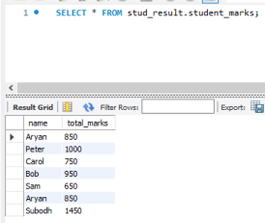

● Create a function that will return the total students in a given class.

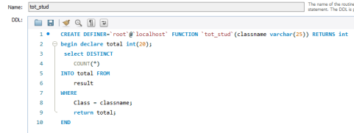**Output:**

